|  |
| --- |
|  |
| SharePoint Bulk Edit and Classify - User Guide |
| Administrators Manual |
|  |
|  |
| **6/13/2017** |

Table of Contents

Introduction 2

Supported Operating Systems 3

Supported SharePoint Versions 3

Supported Browsers 3

Supported List Definitions 3

Supported Base Content Types 4

Supported Field Data Types 4

User Permissions required to use Bulk Edit & Classify 5

Security Notes/Behavior 5

Auto-Check-Out 5

Preserve Author 5

Installation 6

Uninstall 6

Getting Started 7

Support 12

|  |
| --- |
|  |

# Introduction

This application is used to update multiple SharePoint item metadata at once. Other features include auto check-out & auto-check-in functionality for quick updating, updating of Content Types for multiple items, update metadata or bulk recycle items using a query, and bulk updating multiple SharePoint Items and Document metadata quickly from one screen.

Specifications

# Supported Operating Systems

Microsoft Windows Server 2008 x64

Microsoft Windows Server 2008 R2

Microsoft Windows Server 2012 x64

Microsoft Windows Server 2012 R2

# Supported SharePoint Versions

Microsoft SharePoint Server 2016 (as farm solution only)  
Microsoft SharePoint Foundation 2013 or Microsoft SharePoint Server 2013 (as farm solution only)  
Microsoft SharePoint Foundation 2010 or Microsoft SharePoint Server 2010 (as farm solution only)

NOTE: Use appropriate installer for your SharePoint version.

# Supported Browsers

Internet Explorer 7 or greater  
Mozilla Firefox  
Google Chrome

# Supported List Definitions

Custom Lists  
Document Libraries  
Surveys  
Links  
Announcements  
Contacts  
Events  
Tasks  
Discussion Boards  
Picture Libraries  
Web Page Libraries  
Gantt Tasks  
Meetings  
Agenda  
Meetings  
Home Page Libraries  
Issue Tracking Lists

# Supported Base Content Types

Item  
Document  
Event  
Issue  
Announcement  
Link  
Contact  
Message  
Task  
Workflow History  
Page  
Post  
Comment  
East Asia Contact

NOTE: Content Types can be bulk edited for all items

# Supported Field Data Types

Single Line of Text  
Multiple Lines of Text  
Choice  
Number  
Currency  
Date and Time  
Lookup  
Yes/No  
Person or Group  
Hyperlink or Picture  
Calculated  
External Data  
Managed Metadata  
Enterprise Keywords

# User Permissions required to use Bulk Edit & Classify

Users require ‘Read’ Permission Level or greater to be able to use the tool.  
Visitor/Read Permission Level users will see the “Bulk Edit” or “Edit with Query” ribbon button, however if they do not have ‘Edit’ rights on a list item,/file, it will be not be updated and they will receive an error message stating ‘Access Denied’ for those items.

# Security Notes/Behavior

Users who try to edit items that are checked out to another user will still be able to bulk edit and check-in other items, however they will receive an error with log details indicating the item has been checked out to another user, and it will display the username of that user.

# Auto-Check-Out

Items do not have to be checked out to use this tool, once selected and updated, the utility will automatically check-out and (optionally) check-in items with comments included by user. This is to allow quick editing by using “Select All” items check boxes and not having to navigate around checked-in and checked-out items. If the application cannot check out an item (due to insufficient permissions or the item is already checked-out to another user), then the system will give an error for those individual items and will not change them, other items will continue to be updated.

# Preserve Author

Users can optionally preserve Modified By and Modified (date) of items, so when they are bulk updated, these existing values will be retained.

# Installation

Pre-requisite License Installation (Install First)

NOTE: If the pre-requisite license solution has already been installed, you do not need to install it again for other products.

1. Unzip “QIPoint.SP.BulkEdit.zip” to a local drive on one of the Web Front End Servers.
2. Open the folder labelled “SharePoint Licensing Component”

IMPORTANT: Make sure you are logged onto the Web Front End Server as a Farm Administrator

1. Run Setup and follow installation instructions.

QIPoint SharePoint Bulk Edit & Classify Installation

1. If you have not done so already, unzip “QIPoint.SP.BulkEdit.zip” to a local drive on one of the Web Front End Servers.

See this for more information on multiple WFE farm solution deployments:

<http://msdn.microsoft.com/en-us/library/aa544500.aspx>

IMPORTANT: Make sure you are logged onto the Web Front End Server as a Farm Administrator when running Setup. Once the solution is added, an IISRESET is issued to all WFE in the farm automatically.

1. For SharePoint 2010 Server Versions: Open the folder labelled “SharePoint 2010”, run Setup and follow installation instructions.
2. For SharePoint 2013: Open the folder labelled “SharePoint 2013”, run Setup and follow installation instructions.

# Uninstall

1. Go to Central Administration
2. Click “System Settings” on the left navigation pane.
3. Click “Manage Farm Solutions”
4. Click on the solution “qipoint.sp15.bulkedit.wsp”
5. Click “Retract Solution”

NOTE: You do not need to deactivate the feature on all sites, this will automatically be done.

1. Once the solution is retracted successfully, click “Remove Solution”

# Getting Started

1. Once the product solution is installed (see Installation), from your browser, go to the Site in which you want to use this tool.
2. Go to Site Actions->Site Settings->Manage Site Collection Features (under Site Collection Administration heading)
3. Look for the feature “QIPoint Bulk Edit and Classify” and Click on Activate



NOTE: To enable the feature for many Sites, you can use PowerShell to do this. The product was configured/scoped at Site Collection level to give better control to who may use it in your organization. (See <http://technet.microsoft.com/en-us/library/ff607803.aspx> )

*Example: Enable-SPFeature –identity "qipoint.sp15.bulkedit.wsp" -URL http://portal.contoso.com*

Bulk Editing from Web Pages

1. From any SharePoint web page that has a List View Web Part, select one or more items from the list view web part
2. The top ribbon will activate, click on Bulk Edit or Edit with Query

Bulk Editing Lists & Document Libraries

1. Navigate to the library where you would like to bulk update and check-in items
2. Select one or more items
3. Under the Document Tab->Manage (Ribbon Group), you should see the buttons “Bulk Edit” and “Edit with Query” (see screenshot below)

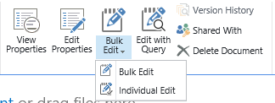

1. After clicking one of the Bulk Edit ribbon buttons, you will receive a pop up window as below. Select the options as appropriate.

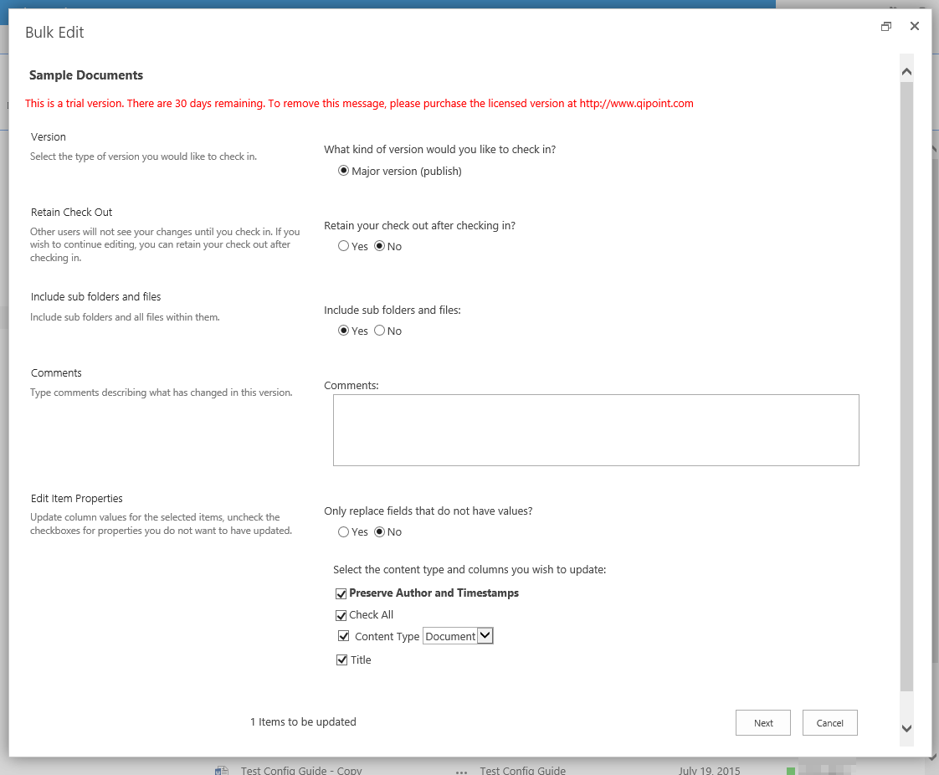

Version

NOTE: Applies to Document Libraries Only. This will display different options depending on library/list versioning settings.

If Versioning is enabled, the first section will provide options to check-in minor or major versions. Otherwise it will only display the available options for the library. In this case versioning is not enabled so only Major versions can be selected.

Retain Check Out

NOTE: Applies to Document Libraries Only

Allows the user to keep the items checked out after the update completes.

TIP: You can easily change the default options for this by modifying the aspx form in the LAYOUTS directory. Contact us for assistance.

Include sub folders & files

If you select “Yes”: folders that are selected will have their contents also recursively iterated through and updated.

If you select “No”: folders selected will not be updated. NOTE: If a folder is selected as one of the items to update, the user will receive an error stating the folder could not be updated because updating Folder Content Types are not supported.

Comments

Optionally you may include comments when the items are checked in. The same comments will be applied to all items.

Edit Item Properties

This section provides all of the fields that can be bulk edited. You may change the Content Type of the items selected and the associated fields will then be displayed. Select/Check only the fields you want to have updated.

In this example, I will select only some of the fields to update. Note I also added a Comment “Just a test”

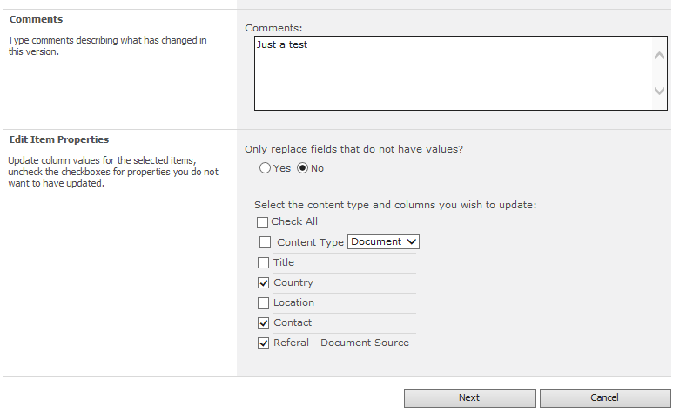

1. Click “Next”
2. You will now see a screen where you can enter the values for the fields you want updated.

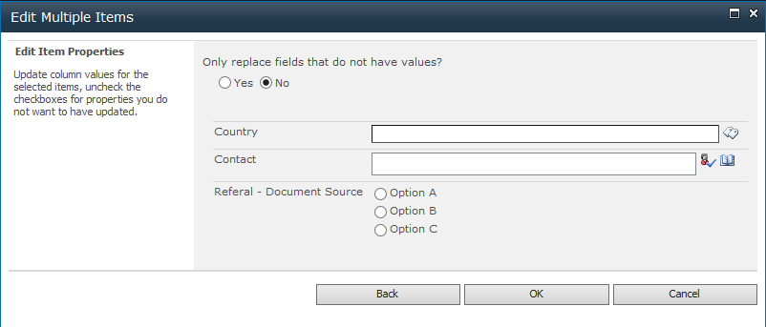

Only replace fields that do not have values?

Select Yes: to only update fields that have no value.

Select No: to overwrite all existing values with those specified on this form.

1. Enter values into the form as you want them to appear for the items selected.

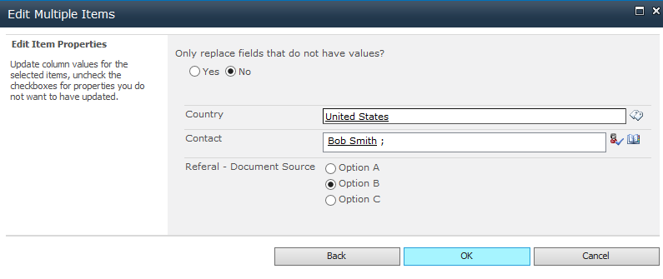

1. When done, click “OK”. At this point validation will occur on the fields. If validation passes (such as fields with numeric data type: will require only numbers), items will now automatically be checked out (if force Check out is enabled) if not already checked out (read more about reasons for this in Specifications section) and will be updated.

The user will see this Processing message while items are being updated:

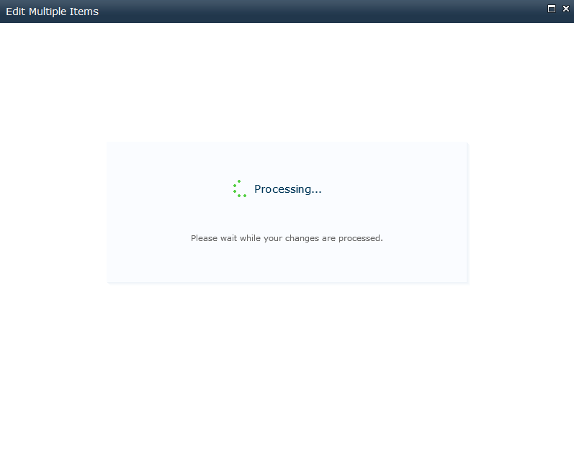

The user will see a notification that the items were successfully updated.

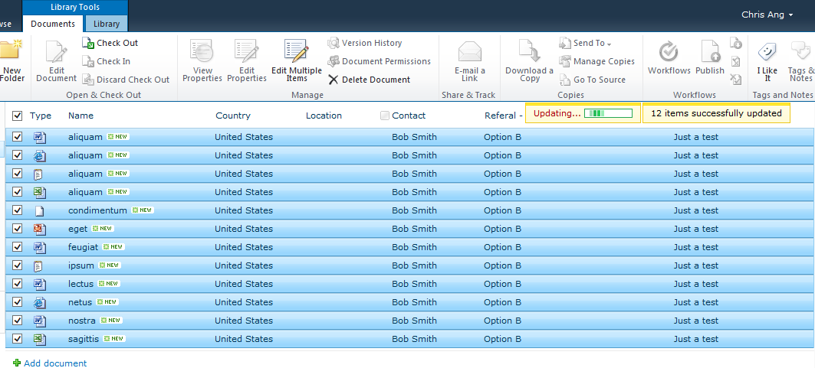

Technical Support

# Support

For further assistance, please contact us at <http://support.qipoint.com>